**Text Analytics Review**

I used the following 5 hotels suggested by Liz to do text analytics on

* Koloa Landing Resort at Poipu
* Westin Princeville ocean resort villas
* [Grand Hyatt Kauai Resort & spa](https://meet.google.com/linkredirect?authuser=0&dest=https%3A%2F%2Fwww.tripadvisor.com%2FHotel_Review-g60625-d87364-Reviews-Grand_Hyatt_Kauai_Resort_Spa-Poipu_Kauai_Hawaii.html)
* Koa Kea Hotel & Resort
* Hanalei Bay Resort

It was a little challenging to work on the data we initially had as it only had 25 reviews per hotel and there is on average anywhere between 1500 – 7500 reviews. Therefore I scrapped more reviews (more than 2500) for the following 5 hotels using UiPath.

The excel files found in the folder are structured under the following column names:

* Review: The review it self
* Title: Title of the review (sentiment can be done on the titles themselves)
* Time: When the review was written (can be used to for trend analysis)
* Location of Reviewer: Can map out and determine where most travelers are coming from
* Number of previous reviews: Can filter out reviewers with 1 or 2 reviews to avoid any biasness

I know a lot of this is out of our scope, but figured I would pull the data if you wanted to talk about possible future objectives in the report.

**Analysis:**

**Koloa Landing Resort at Poipu**

Notable Common words: Pool, Beach, Location

Words of concern: Construction (mentioned over 7000 times)

The reviews are ordered from newest to oldest. Therefore studying these words in a dispersion plot it seems “construction” came up a lot towards the end of the reviews (oldest). It was mentioned one time in 2017.

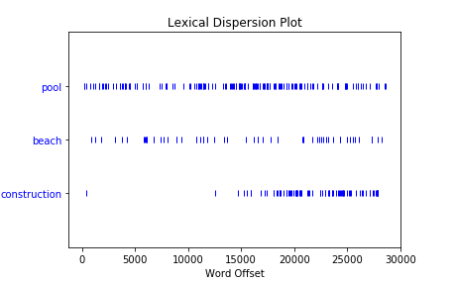

Average sentiment score: 0.165

Average sentiment score around “beach”: 0.226

**Westin Princeville ocean resort villas**

Notable Common words: Pool, Comfortable, Loved

Words of concern: Construction (mentioned over 30000 times), small (mentioned over 45000)

Once again studying the dispersion plot “construction” and “small” were densely used in initial reviews. The word “small” still appears in newer reviews but is more spaced out. Using the concordance tool it was determined “small” was most often used to describe the studio/kitchen size. The reason for the word to be more spaced out in the newer reviews could be because newer units were added that are more spacious.

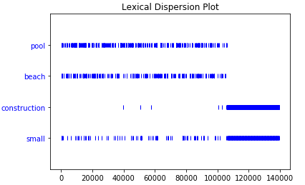

Average sentiment score: 0.181

Average sentiment score around “beach”: 0.179

[**Grand Hyatt Kauai Resort & spa**](https://meet.google.com/linkredirect?authuser=0&dest=https%3A%2F%2Fwww.tripadvisor.com%2FHotel_Review-g60625-d87364-Reviews-Grand_Hyatt_Kauai_Resort_Spa-Poipu_Kauai_Hawaii.html)

Notable Common words: Pool, Wonderful, Restaurants, Grand, Beach

Words of concern: There were no real words of concern that appeared consistently; however “construction” even though not a popular word in the reviews did appear densely in more recent reviews.

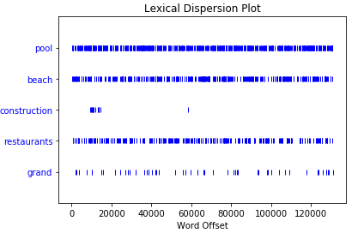

Average sentiment score: 0.176

Average sentiment score around “beach”: 0.191

**Koa Kea Hotel & Resort**

Notable Common words: Best, Perfect, Honeymoon, Quiet,

Words of concern: There is no mention of construction at all but the word small did appear a lot. Using the concordance tool, “small” did not have a negative connotation when used in most sentences. It was closely used with the word intimate. The hotel seems be more suitable for a romantic getaway.

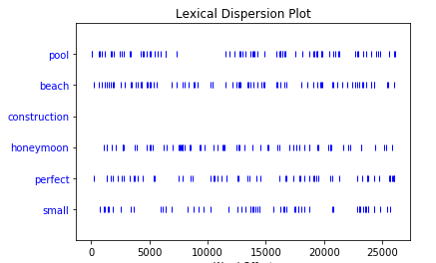

Average sentiment score: 0.182 (highest sentiment score)

Average sentiment score around “beach”: 0.247 (highest sentiment score)

**Hanalei Bay Resort**

Notable Common words: Pool, Beach, Amazing, Week, Recently

Words of Concern: I found it odd how the word “recently” popped up quite a few times. Looking further into how the word was used in sentences, it seems the place was recently renovated. This further explains why the word “construction” appeared in some of the recent reviews

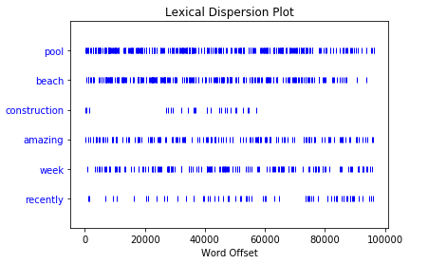

Average sentiment score: 0.173

Average sentiment score around “beach”: 0.219